Assignment 1

Describe in your own words what an X-gate, Z-gate, and R-gate do. Which matrix corresponds to each gate?
The X-gate, or the Pauli-X gate is the bit flip gate, and it works on a single qubit. It works like a classical NOT gate where it inverts a binary bit. In the quantum circuit, it flips a qubit state, switching from |0⟩ to |1⟩ and vice versa. Below is the matrix form of the X-gate:
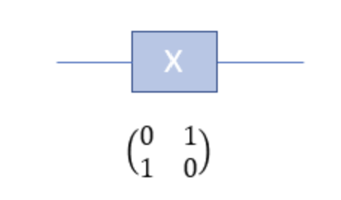
The Z-gate, or the Pauli-Y gate, is the phase-flip gate, and it works on a single qubit. It modifies the phase of the qubit state without changing the basis states. If the Z-gate is applied to a qubit in state |0⟩, the qubit will remain unchanged. If we apply the gate to a qubit in state |1⟩, the qubit state changes to -|1>. Below is the matrix form of the Z-gate:
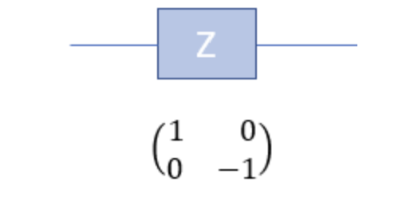
Below are some visual examples of applying the gate:
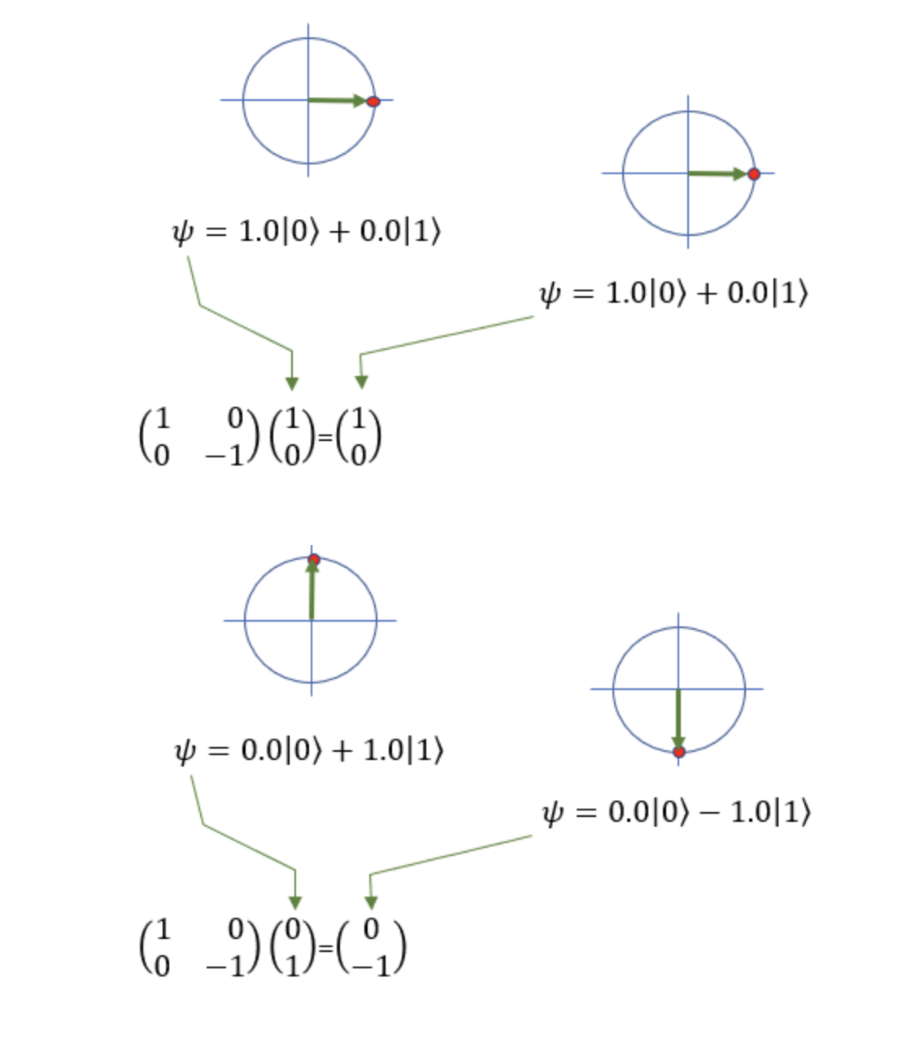
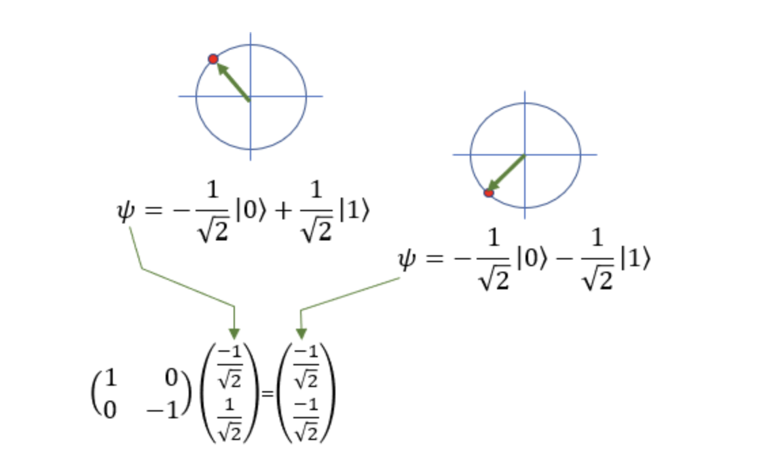
The R-gate is the rotation gate that performs rotations on a qubit around a specific axis of the Bloch sphere. The R(x)(θ) gate is for the rotation around the X-axis, the R(y)(θ) gate is for the rotation around the Y-axis, and finally the R(z)(θ) gate is for the rotation around the Z axis. All of them rotate by an angle θ (in radians). The following are the matrixes that correspond to the gate operations for the 3 types of rotation gates:

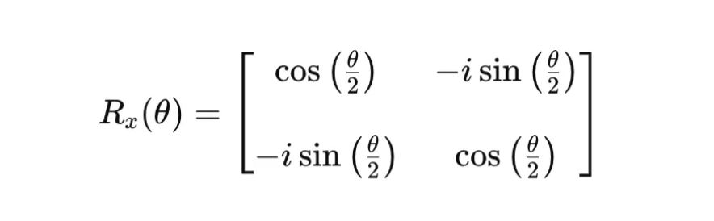
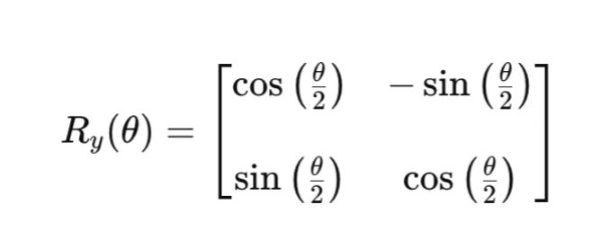
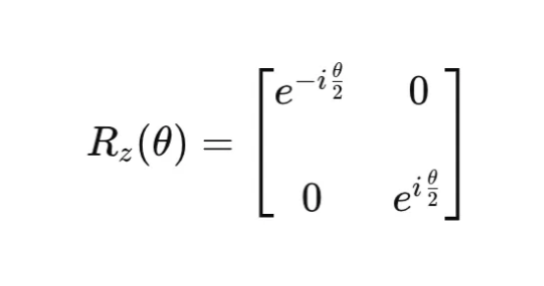

Which classical logical operations resemble the behavior of these quantum gates
Among the quantum gates considered, only the X-gate has a direct classical analogue. The X-gate flips the computational basis states ∣0⟩ and ∣1⟩, which is equivalent to the action of a classical NOT gate. In contrast, the Z-gate does not have a corresponding classical logical operation. Although it leaves the state ∣0⟩ unchanged, it applies a phase shift of −1 to the state ∣1⟩, and since classical bits do not carry phase information, this operation has no classical equivalent. Similarly, rotation gates perform continuous rotations to the qubit. Classical logic gates are discrete and cannot represent such continuous phase transformations, so no classical logical operation corresponds to the R-gate either.

Build a circuit in Qiskit with one qubit and apply the X-gate, Z-gate, and Rz(π/4)-gate one after the other.

What do you expect the final state to be?
The circuit starts with one qubit initialized in the state ∣0⟩. Applying the X-gate flips the qubit from ∣0⟩ to ∣1⟩. The subsequent Z-gate applies a phase flip to the ∣1⟩ state, resulting in the state −∣1⟩. Finally, applying the Rz(π/4) gate introduces an additional phase factor of e^i π/8. Therefore, the final quantum state of the qubit is –e^i π/8 ∣1⟩.

Run the circuit on a simulator and discuss the output.
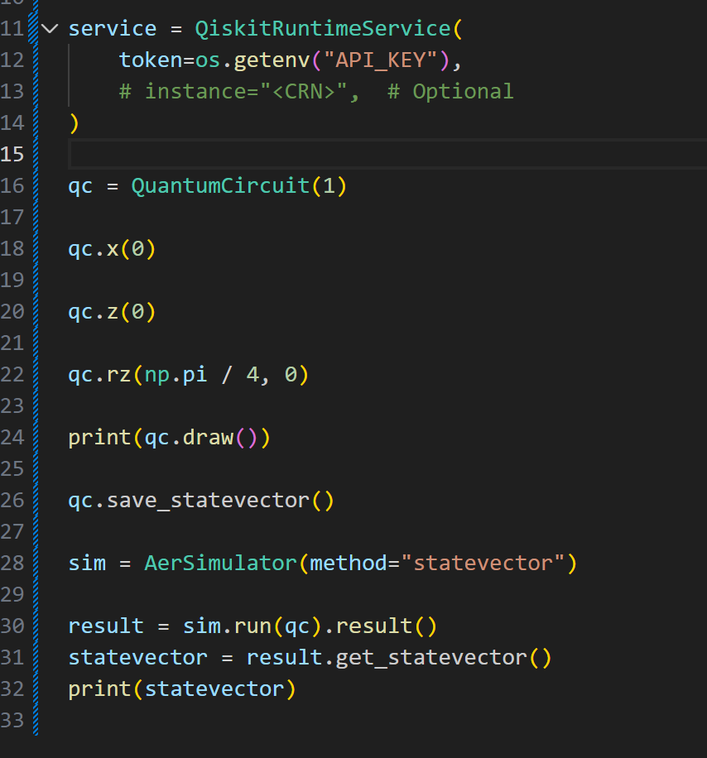
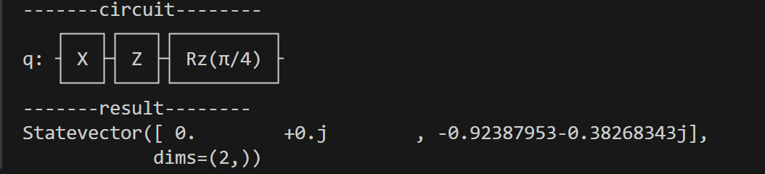
After running the circuit on a statevector simulator, the final quantum state has amplitude only on ∣1⟩ and zero amplitude on ∣0⟩. The amplitude on ∣1⟩ is a complex number close to
−0.9239 −0.3827𝑖 which matches the theoretical value of −𝑒^𝑖𝜋/8. Therefore, although Z and 𝑅𝑧(𝜋/4) change the phase of the qubit, they do not change the measurement probabilities, so the qubit would still always be measured as ∣1⟩.

Experiment

What changes if you alter the order of the gates?
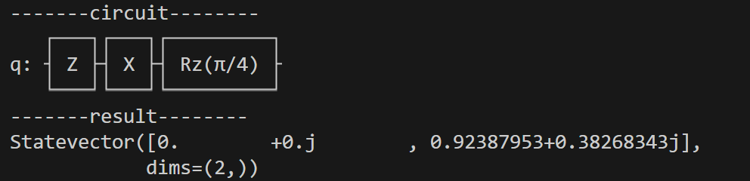
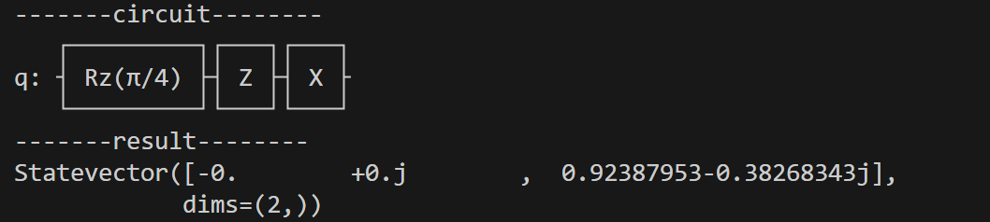
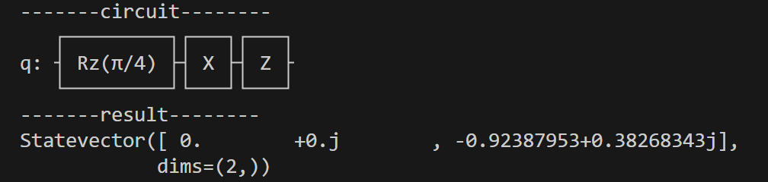
Altering the order of the quantum gates changes the phase of the resulting quantum state. Although the final state still has all its amplitude on the ∣1⟩ basis state, the complex coefficient associated with this state may differ by a sign or phase factor. This occurs because changing their order can introduce different phase contributions. However, the magnitude of the amplitude remains unchanged, meaning that the measurement probabilities are the same. As a result, the qubit is still measured as ∣1⟩, and the difference between the resulting states is only a global phase, which has no observable effect on measurement outcomes.

Add a measurement operation and explain the result.
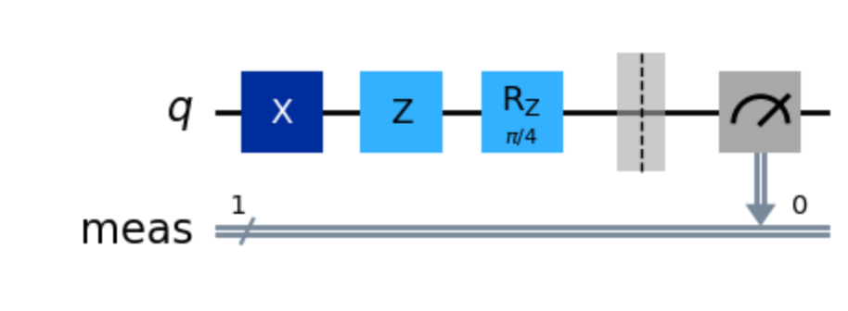
Measurement result: {'1': 1024}
After adding a measurement, the qubit’s quantum state is collapsed into a classical value.
By using a classical simulator, measurement always returns 1 after repeating the experiment 1024 times. The phase information introduced by Z and Rz gates does not affect the measurement outcome in the computational basis.
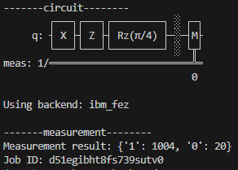
In contrast, when the same circuit is executed on a real quantum processor, a small number of measurements return 0. This can occur due to noise in physical quantum hardware. These imperfections slightly disturb the quantum state and lead to occasional incorrect measurement outcomes. However, the dominant result remains 1, confirming the expected behavior of the circuit.

Assignment 2

Explain in your own words what superposition and entanglement mean. Why
are these concepts fundamental to quantum computing?
Superposition means that a quantum bit (qubit) can be in a combination of ∣0⟩ and ∣1⟩ at the same time. Instead of holding only a single definite value like a classical bit, a qubit can represent both possibilities simultaneously, each with a certain probability. This allows a quantum computer to explore many possible states in parallel, which is one of the key reasons it can outperform classical systems on certain problems.
Entanglement is a strong connection between two or more qubits where the state of one qubit is directly linked to the state of the other, even if they are far apart. If you measure one entangled qubit, the outcome of the other is instantly determined. The qubits stop behaving independently and instead act like a single combined system.
These concepts are fundamental because:
- Superposition gives quantum computers the ability to process many states at once, enabling massively parallel computation.
- Entanglement allows qubits to coordinate their behavior in ways classical bits cannot, enabling powerful algorithms, secure communication, and speed-ups in tasks like search and factoring.

What is the function of the CNOT gate? How does it work in combination with superposition?
The CNOT gate (Controlled-NOT) acts on two qubits: a control and a target.
- If the control qubit is 0, the target qubit stays the same.
- If the control qubit is 1, the gate flips the target qubit (0 → 1, or 1 → 0).
In other words, the gate performs a conditional NOT operation controlled by the value of the first qubit.
When combined with superposition, the CNOT gate does something uniquely quantum: it creates entanglement.
Example:
If the control qubit is put into superposition (using a Hadamard gate), it becomes both 0 and 1 at the same time.
When a CNOT is applied afterward:
- In the part of the state where the control is 0, the target stays the same.
- In the part of the state where the control is 1, the target flips.
This causes the qubits to become linked — neither qubit has its own independent state anymore. The result is an entangled pair, such as a Bell state.
So, the CNOT gate’s role is not just to flip bits. It's true power appears when it acts on qubits already in superposition, enabling the creation of entangled states, which are essential for quantum algorithms and quantum communication.

Build quantum circuit with two qubits:

Applied Hadamard gate to the first and CNOT gate with the first qubit as control and the second as target.
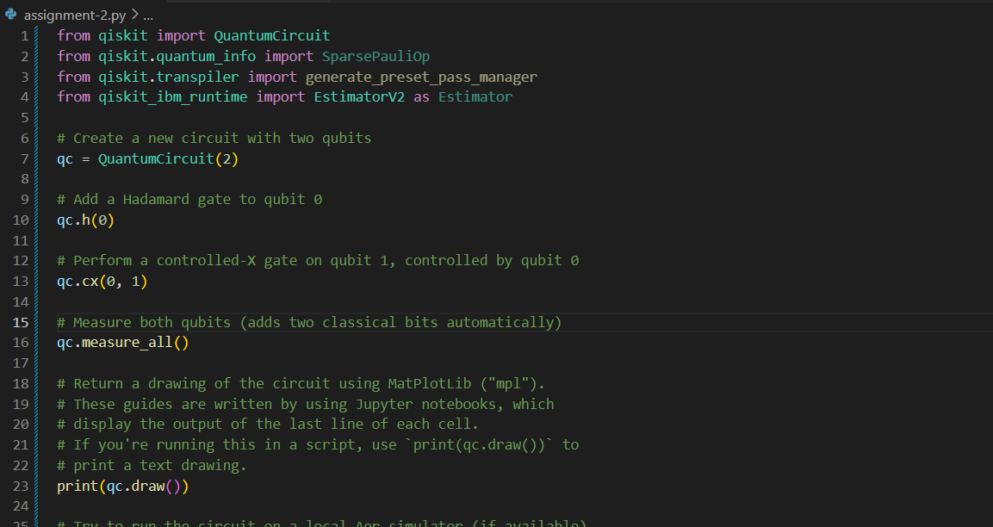Fig. 1 – circuit build.

Measurement of both qubits after multiple executions.
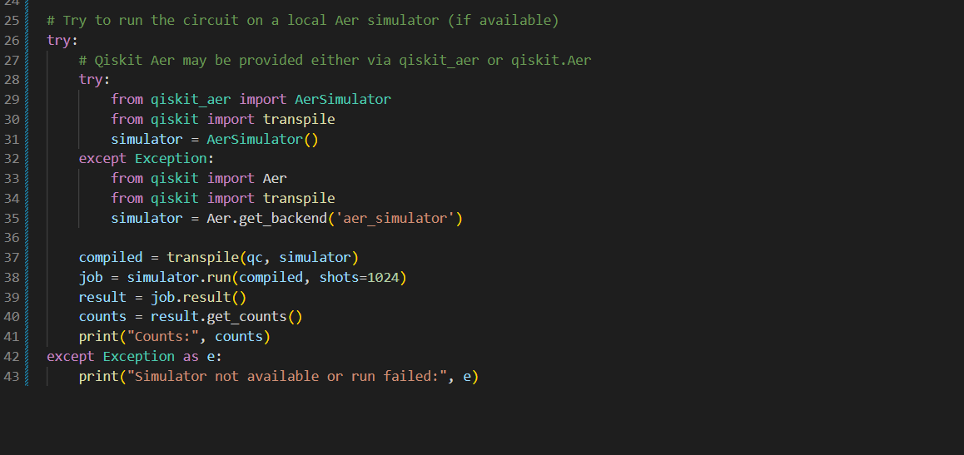Fig. 2 – multiple executions and results capturing.

Analyze the results:
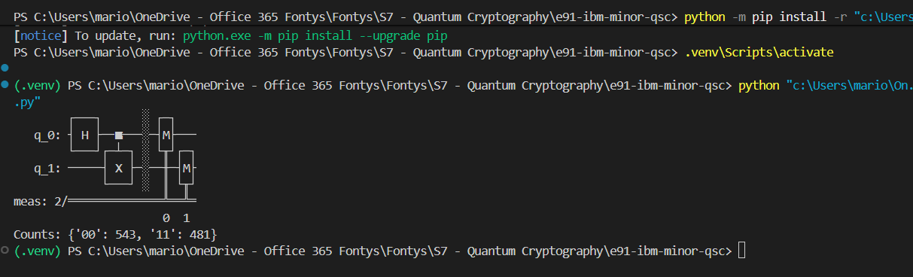Fig. 3 – analysis results.

What does the output say about the correlation between the qubits? How does it apply when the simulation is run a lot of times?
The measured outcomes show only the two bitstrings |00> and |11>, with counts {'00': 543, '11': 481} for 1024 shots total. This indicates the two qubits are strongly correlated: after H on qubit 0 and a CNOT (control=0, target=1) the system is in the Bell-type superposition (|00> + |11>)/√2. Individually each qubit appears approximately random (each outcome near 50%), but the joint results are perfectly correlated — whenever one qubit is 0, the other is 0, and whenever one is 1, the other is 1. These statistics are consistent with the creation of a maximally entangled state. The small ≈3% deviation from a perfect 50/50 split is within expected sampling variation for 1024 shots.

Assignment 3

Briefly describe the purpose of the E91 protocol. How does it differ from classical key distribution?
The E91 protocol is a quantum key distribution scheme that uses pairs of entangled photons to allow two parties to establish a shared secret key. By measuring their photons in randomly chosen bases, and by checking statistical correlations that violate Bell inequalities, they can verify that no eavesdropper has interfered with the system.
Its key distinction from classical key distribution is that security comes from the fundamental behaviour of entanglement rather than computational assumptions. Any attempt to intercept or measure the quantum states inevitably disturbs the entanglement and reveals the presence of an eavesdropper, something classical methods cannot guarantee.

Implement the circuit in Qiskit. Use Hadamard and CNOT gates to create entanglement.
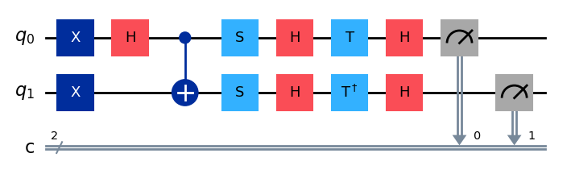

What is a Bell test and why is it relevant in the E91 protocol?
A Bell test is an experimental check of whether measurement outcomes on two separated systems show correlations that cannot be explained by any local hidden-variable theory. In practice, it involves choosing different measurement settings on each side and verifying that the resulting statistics violate a Bell inequality.
In the E91 protocol, the Bell test is essential because it allows the communicating parties to confirm that their photon pairs are genuinely entangled and that no eavesdropper has tampered with the quantum channel. If an attacker tried to intercept or reproduce the states, the expected Bell-inequality violation would be reduced or lost, signalling that the key would no longer be secure.

Simulate a Bell test in your circuit. What does the test demonstrate?
A Bell test in the E91 circuit demonstrates quantum entanglement and proves that the shared quantum state violates classical physics constraints.
The CHSH (Clauser-Horne-Shimony-Holt) inequality measures correlations between Alice's and Bob's measurements when they choose different measurement bases. If the qubits were just regular classical bits with predetermined values (local hidden variables), the CHSH parameter S must satisfy |S| ≤ 2. For entangled qubits like the singlet state, quantum mechanics predicts $\left|S\right| ≤ 2\sqrt{2} ≈2.828$.
The test demonstrates that the qubits are genuinely entangled, that no eavesdropper has measured and resent the qubits, and that the quantum channel is secure.

Interpret the results of your circuit:
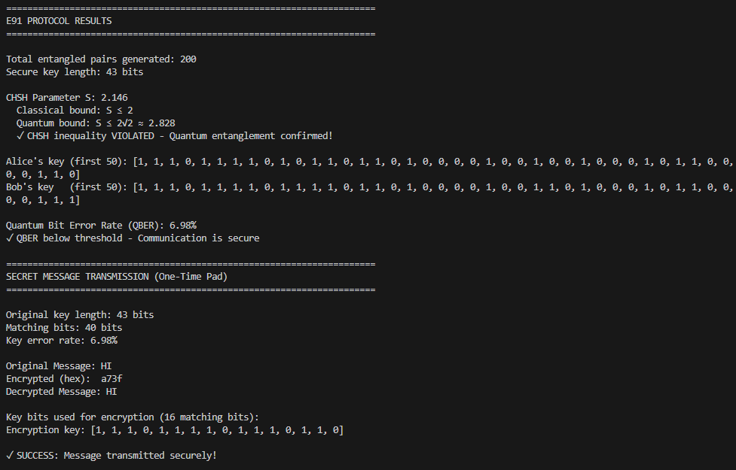

How do the measurements relate to each other?
The measurements in E91 have specific correlation patterns:
- Anti-correlation in matching bases: When Alice and Bob measure in the same basis (a₂/b₁ for W or a₃/b₂ for Z) on the singlet state, they get opposite results. If Alice measures 0, Bob measures 1, and vice versa. This is why we flip Bob's bit to create matching keys.
- Quantum correlations for CHSH bases: When measuring in the bases used for the Bell test (a₁/b₁, a₁/b₃, a₃/b₁, a₃/b₃), the correlations are stronger than classically possible. The correlation strength depends on the angle between measurement directions.
- Random outcomes in non-matching bases: When Alice and Bob use incompatible bases, their results appear random and uncorrelated. These measurements are discarded during key generation.
- Entanglement signature: The CHSH parameter S > 2 indicates the measurements are correlated in a way that's impossible for classical particles, proving the qubits were entangled when measured.

What do these results say about the security of the generated key?
The results provide several security indicators:
- CHSH violation (S > 2): If the CHSH parameter exceeds 2, it proves the channel is secure. No eavesdropper intercepted and re-sent qubits, because that would destroy entanglement and bring S ≤ 2. This is unique to E91 - security is guaranteed by fundamental physics (Bell's theorem).
- QBER (Quantum Bit Error Rate): Low QBER (<11%) indicates minimal interference. In your results, QBER shows what percentage of bits differ between Alice and Bob's keys due to noise or potential eavesdropping.
- Key matching rate: After filtering for matching bits, the percentage of matching bits indicates channel quality. High matching rate = secure channel with low noise.
- Statistical security: The more matching bits you have after filtering, the more confident you can be that errors are random noise rather than eavesdropping attempts.

Assignment 4

Describe as many causes of channel loss in the E91 protocol as possible. Provide a detailed and specific description of each cause, along with a quantification using a formula (one formula per cause).
Every protocol has distance limitations due to these losses that grow with the transmission distance.
- Geometrical Loss (Sisodia et al., 2023)
  - In E91, entangled photons propagate through free space or fiber. Geometrical loss occurs due to the spreading of the beam propagating from the transmitter to the receiver which causes only a fraction of the photons to enter the receiver aperture.
  - It can be calculated using the following formula: ${\left[\frac{d_{r}}{d_{t + DL}}\right]}^{2}$
  - $d_{r}$ and $d_{t}$ are the diameters of the receiver and transmitter apertures, D is the beam divergence, and L is the channel length.
  - The loss dominates short laboratory distances
- Atmospheric Loss (Sisodia et al., 2023)
  - Photons are absorbed and scattered by molecules, aerosols, water vapor, and gases.
  - This loss is described by the Beer-Lambert’s law $τ = \exp\left(-αL\right)$ dB/km, where $α$ is the atmospheric attenuation coefficient that includes the absorption and scattering of the atmospheric medium
  - This loss dominates long-distance free space links, which exponentially increases with channel length, L.
  - The formula for total atmospheric loss is the following: $T = {\left[\frac{d_{r}}{d_{t + DL}}\right]}^{2}\exp\left(-αL\right)$
- Optical fiber Attenuation Loss (Marin, 2020)
  - Attenuation in an optical fiber means that photons are gradually lost as they propagate through. This occurs due to absorption by the material and scattering of photons due to density.
  - As in E91, we need both photons of the entangled pair to arrive, losing either of the photos will destroy the entanglement.
  - Entangled photons face exponential loss with distance (order of 0.2 dB/km in telecom wavelength fiber)
  - We can calculate the transmission efficiency using the formula: $n_{fiber}={10}^{-\frac{α_{f}L}{10}}$
  - $α_{f}$ is the fiber attenuation coefficient and L is the fiber length.

References
- Sisodia, M., Omshankar, Venkataraman, V., & Ghosh, J. (2023). FSO-QKD Protocols under free-space Losses and Device Imperfections: A Comparative study. Quantum Photonics Lab, Department of Physics, Indian Institute of Technology Delhi, New Delhi, 110016, India. https://link.springer.com/article/10.1007/s11128-024-04382-1
- Marin. (2020, April 14). Entanglement-Based QKD Protocols: E91 and BBM92. PostQuantum - Quantum Computing, Quantum Security, PQC. https://postquantum.com/post-quantum/entanglement-based-qkd/#fiber-vs-free-space-satellite

